**Thank you for purchasing the JD’s Garage Plasma Cutter Plans - Rotary Axis Addition**

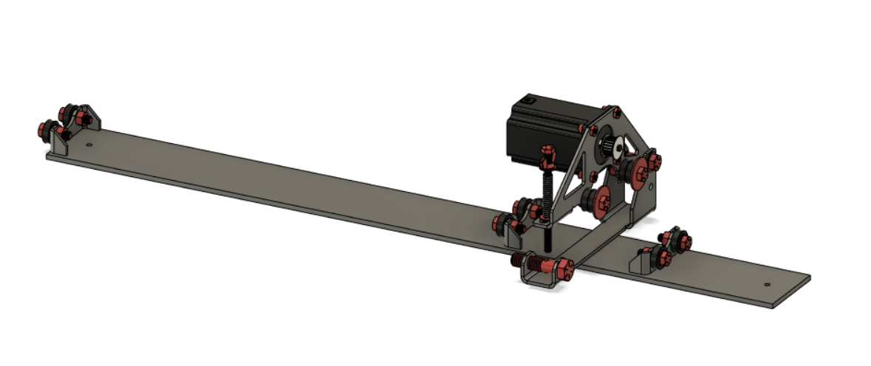

**What’s Included…**

.dxf files so you can cut out the parts yourself

.gcode with settings for cut parts

BOM with links to purchase

Step by Step Assembly Instructions

**Sections:**

1 Bearing Mounts

2 Tube Roller

3 Final Assembly

.dxf files and gcode

**How to get the most out of these instructions…**

1. Follow the sections is order it will make things easier
2. Read sections 1-3 before starting the build
3. Start by cutting out the sheet metal parts
4. Use the .gcode and settings provided if you have not cut anything out on the plasma table before. **THESE SETTING WILL ONLY WORK IF YOU ARE USING THE LOTOS LT5500D Plasma Cutter**
5. Watch build videos if you are confused as to how something may go together https://youtu.be/OjYK7rzeigI

LEGAL: JD’s Garage is the sole creator and owner of these plans. JD’s Garage is the only source for these plans. JD’s garage does not authorize these plans to be resold or redistributed in any form or modification hereafter. JD’s Garage does not authorize resale, or redistribution in any form. Plans user (you) releases, discharges, and relinquishes all liability from JD’s Garage when opening these plans. JD’s Garage retains indemnity, is saved, protected, and held harmless from all forms of liability from the use of these plans. Plans User (you) assume all responsibility and liability from the moment you view, share and/or use these plans.